**Issues found:**

**Referrals – Role: Employee**

1. Submit your referral pop up

* No error messages for fields (when proper format is not followed).
* Phone number accepting alphabets.

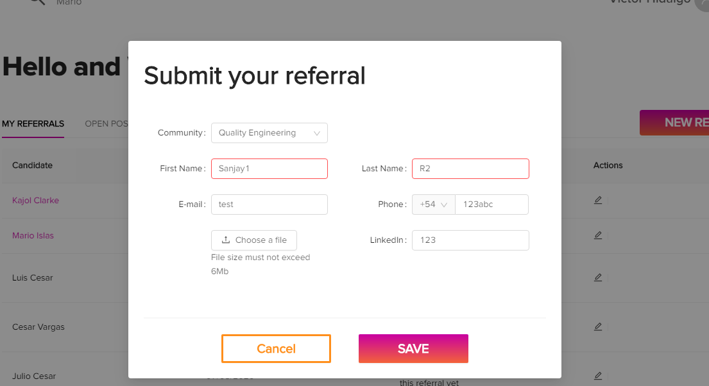

1. Search Bar in referrals page.

* Search bar is not working.

